Minutes of the Meeting of Glapwell Parish Council, held on Thursday 27th July 2023 in the Glapwell Centre, The Green, Glapwell

**Members present:**

Cllr T Trafford

Cllr C Fleetwood

Cllr I Grainger-Grimes

Cllr R Hibbert

Cllr J Ritchie

**Apologies**

Cllr P Clough

Cllr D Harvey

**In attendance**

J Marriott (Responsible Finance Officer)

Dr J Clarke (Parish Clerk)

**Public Participation**

No members of the public attended.

**BUSINESS**

**01/07/23 Apologies for absence**

Apologies received from Patricia Clough and David Harvey.

**02/07/23 To receive declarations of interests**

Cllrs Trafford, Clough and Fleetwood declared a personal interest as Trustees of the Glapwell Guardians.

All councillors present declared a personal interest in the Glapwell Community Sports Association.

Cllr Richie declared a personal interest in Glapwell Cricket Club,

**03/07/23 Minutes**

**RESOLVED That these minutes were approved as an accurate record of the meeting held on Thursday 22nd June 2023.**

**04/07/23 Exclusion of Public**

Not required.

**05/07/23 Reports**

1. **Parish Clerk’s report**

A written report was submitted.

**RESOLVED That this information be received and that based on the report the following actions would be taken.**

1. That the Clerk would prepare a bid for the next round of the Community Ownership Fund for the replacement Community Centre.
2. **District Councilor’s report**

Cllr Ritchie gave a verbal report including illegal dog breeding in Glapwell. He was asked to enquire into the S106 monies for the development at Glapwell Nurseries. A discussion took place with regards to infill housebuilding in the parish.

1. **County Councilor’s report**

Cllr Barron was not present. In his absence several issues were raised:

1. The state of the road near Hall Corner after being repeatedly dig up. The Clerk would raise this with DCC.
2. Cllr Hibbert questioned whether the promised funding for the Coronation Tea had come through. The Clerk would explore this.
3. **Police Report**

PC Hancock had been in touch about a resident who had been involved in an incident at the Centre. The resident had been sectioned under the Mental Health Act.

The monitor of the CCTV was failing. The Clerk would replace this.

1. **Glapwell Centre Manager’s report**

A written report was submitted.

**RESOLVED That this information be received and that based on the report the following actions would be taken.**

1. That the uneven flags around the centre were re-laid or replaced.
2. That the cost of a recycling bin be explored.
3. That the rate that other local venues hire out their halls be benchmarked against the Parish’s charges,

**06/07/23 Planning**

No applications.

**07/06/23 Items for Consideration and Decision**

- **Renovation of the community centre (standing item).** The Centre roof was leaking badly and this needed to be addressed before winter.

- **The football ground and MUGA (standing item).** The Clerk and the Centre Manager had visited Hall Corner and had concerns about the dilapidation of the club house and the state of the inside, particularly as children would be using it. Newsletter

- **Playground equipment repair and removal.** A quote had been received from BDC for safety interventions on the children’s play area adjacent to the centre.

- **Lease of the cricket ground.** The cricket club needed a lease in order to apply for funding to upgrade the Clubhouse. Some work for a lease on the football club had already been done and could be adapted.

- **Request by Clerk to do CILCA course.**

**- Remembrance Sunday arrangements.**

**RESOLVED That:**

1. the Clerk and RFO explore applying for PWLB funding for a roof repair for the Community Centre.
2. That the Clerk would seek quotes for the repair.
3. That the support staff could be offered further hours funded by GCSA to do some remedial work at Hall Corner.
4. That the Clerk should commission BDC to repair the equipment at the play area. Bolsover DC have quoted a cost of £1,925 ex VAT. This was accepted without the need for two other quotes.
5. That the Clerk would explore sorting a lease out for Glapwell Cricket Club and in the meantime offer them a letter of comfort.
6. That the Parish would pay for the Clerk to do CILCA training.
7. That the Clerk would purchase a wreath.

**08/07/23 Items for Information Only**

1. **Correspondence**

None received

1. **Items for Information**

None received

**09/07/23 Finance**

1. Payments for authorisation

Council received the list of payments for authorisation for approval.

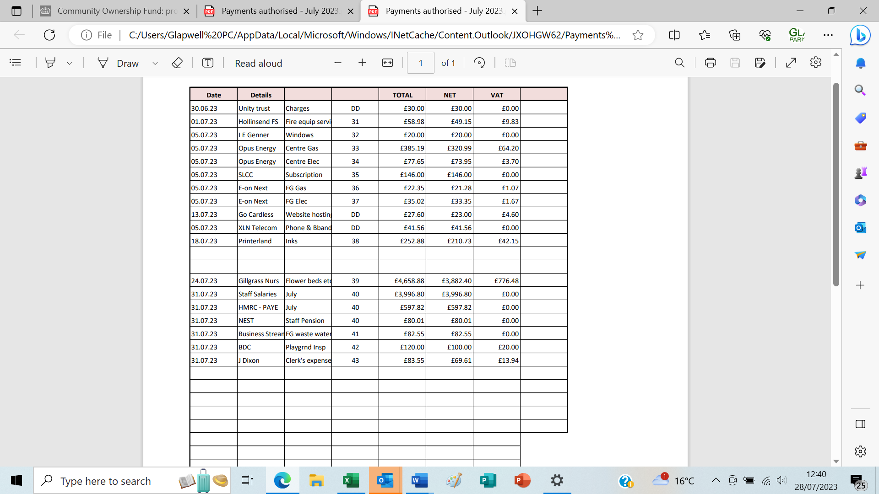

1. Income and expenditure, bank reconciliation

The Responsible Financial Officer presented the Income and Expenditure Account for June 2023 and bank reconciliation as at that date.

1. Budget monitoring to 30th June 2023

The Responsible Financial Officer presented the budget monitoring report.

**RESOLVED That these are received and approved**

**10/07/23 Items to be included on the next agenda (Thursday 28th September 2023)**

None

**Meeting closed at 9.29 pm**

**Chair:_________________________________________ Date:________________________**